Coronary Heart Disease Prediction Using Machine Learning

ABSTRACT

Heart disease is one of the most significant causes of mortality in the world today. Prediction of cardiovascular disease is a critical challenge in the area of clinical data analysis. The diagnosis of heart disease through traditional medical history has been considered as not reliable in many aspects. The health care industry produces a huge amount of data and these data is not always made use to the full extent and is often underutilized. Using this huge amount of data, a disease can be detected, predicted or even cured. In this project, we have developed a Machine Learning based diagnosis system for heart disease prediction by taking the help of medical data such as Blood pressure, cholesterol, body mass index, smoking habit, heart rate etc as input and then these features are modelled for prediction. This model can then be used to predict future medical data. Here we perform the comparative analysis of the algorithms like decision tree, Naïve Bayes, Logistic Regression, KNearest Neighbors .Then the accuracy of the model using each of the algorithms will be calculated and the one having the best accuracy will be taken as the model of predicting the heart disease and finally a GUI will be designed to predict the disease.

Tools used: - Anaconda Framework
Editor: - Jupiter Notebook
Packages Used: -Pandas, numpy, matplotlib, seaborn, sklearn

1.INTRODUCTION
The Heart is one of the most important organs in the human body. It is the centre of the circulatory system. The heart functions as a pump that propels blood to different parts of the human body through a network of blood vessels, supplying a constant supply of oxygen as well as other vital nutritional components. If the heart ever stops functioning and ceases to pump blood, the body will shut down and within very less time a person will expire.

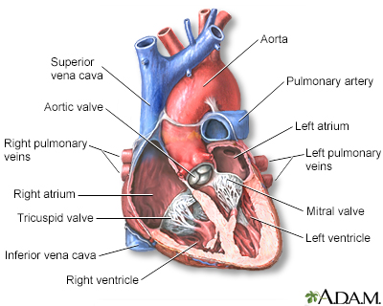
2 What is coronary heart disease?
Coronary heart disease (CHD) is also called as coronary artery disease. The coronary arteries are the blood vessels that carry blood to your heart. Coronary artery disease is the narrowing or blockage of the coronary arteries. This condition is usually caused by atherosclerosis. Atherosclerosis is the build-up of cholesterol and fatty deposits (called plaques) inside the arteries. These plaques can clog the arteries or damage the arteries, which limits or stops blood flow to the heart muscle.
If the heart does not get enough blood, it cannot get the oxygen and nutrients it needs to work properly. This can cause chest pain (angina) or a heart attack.
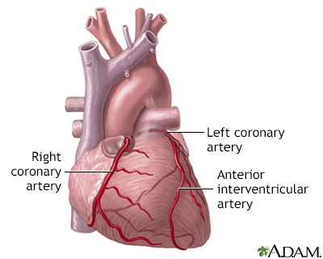
Coronary artery disease (CAD) is the most common type of heart disease in the United States. It is sometimes called ischemic heart disease.

coronary arteries supply blood to the heart muscle. The right coronary artery supplies both the left and right heart, the left coronary artery supplies the left heart.

3 What is Machine learning?
Machine learning is a subfield of artificial intelligence (AI).Artificial intelligence (AI) refers to the simulation of human intelligence in machines that are programmed to think like humans and mimic their actions. Machine learning is the set of different methods that can be used to find patterns from the dataset and then use those patterns to predict future conditions or to make efficient decisions under some conditions. Machine learning introduces different algorithms that can be used to make understanding of the current situations to machine and then based upon that machines can take decisions. Machine learning can make decisions independently at its own.

4 Objective
Heart problems have gained a lot of interest in medical research because of their impact on human health where early diagnosis is critical to delaying the development of heart disease, the world's leading cause of death. thus, it is much needed to predict the possibility of occurrence of heart disease based on their attributes.
This research aims into a variety of machine learning classification algorithms for predicting heart disease using Framingham dataset.

5. Literature Survey
Current approaches To predict heart disease

1. Heart Disease Prediction Using Machine Learning and Data Mining Techniques: Application of Framingham Dataset.Turkish Journal of Computer and Mathematics Education.Vol.12 No.14(2021), 4864- 4870.Walaa Adel Mahmoud , Prof. Dr. Mohamed Aborizka ,Prof. Dr. Fathy Ahmed Elsayed Amer2

In this research work The 10-fold cross-validation resampling is used to validate the prediction model. 5 different machine learning algorithms (KNearest Neighbors,Logistic Regression,decision Tree,Random Forest and support vector machine )are used in this work. Accuracy scores of each algorithm are evaluated.
KNearestNeighbors-83.95 %
SupportVectorMachine-84.5 %
DecisionTree-84.82 %
LogisticRegression-84.89 %
RandomForest-85.05 %
The Random Forest algorithm is found to have highest accuracy.
Remark
In this approach the features are not standardized .
2. Machine Learning-Based Classification Algorithms for the Prediction of Coronary Heart Diseases.
Kelvin Kwakye & Emmanuel Dadzie
Remark
In this approach missing values are handled by mean values

6. Problem definition

In this project the task is to predict whether a person is going to have coronary heart disease or not in upcoming 10 years by using 6 popular machine learning algorithms. These are logistic regression, K Nearest neighbours, Naïve bayes , Decision tree ,Support vector machine and random Forest algorithm. After implementing these algorithms, the best model will be found for heart disease prediction. A graphical user interface will be designed for to make prediction for new dataset.

7. Heart disease data set
This dataset is located at Kaggle website. The dataset contains 16 attributes in all, of which 15 are independent factors and one variable i.e., TenYearCHD is the dependent variable or target variable. This data set contains total 4240 data. All attributes in data set are numeric.
The 16 attributes that are defined here are as follows
Attribute & description
Age | (32-70)
Sex | 0=Female, 1=Male
Education | It takes values as:  1=High School,  2=High School or GED,  3=College or Vocational School, 4=College
Current Smoker | 0=No  1=Yes
Cigs Per Day | Number of Cigarettes smoked Per Day (0-70)
BP Meds | 0=No  1=Yes
Prevalent Stroke | 0=No  1=Yes
Prevalent Hyp | 0=No  1=Yes
Diabetes | 0=No  1=Yes
Tot Chol | Serum Cholesterol (107-696) (mg/dl)
Sys BP | (83.5-295) (mm/hg)
Día BP | (48-142.5) (mm/hg)
Body Mass  Index | (15.54-56.8)
Heart Rate | Heart Rate achieved (44-143)
Glucose | (40-394) (mg/dl)
10-year CHD | 0=Healthy, 1=Diseases

8. Experimental set up and evaluation

Components to be installed:
Anaconda (python 3.9)
Python Packages to be installed
- pandas- used to provide fast, flexible and expressive data structures to make working with “relational” or “labeled” data both easy and intuitive.
- numpy: To work with arrays
- tkinter- used for developing Graphical User Interface (GUI).
- sklearn- efficient for data mining and data analysis. It contains a number of algorithms which can be implemented directly when required.
- matplotlib- contains modules which are used for plotting graphs.
- Seaborn – used for Graphical Presentation

9 Methodology

Data preprocessing
- Remove unnecessary columns
- handle missing values and outliers
Raw dataset

Exploratory Data Analysis

Split data set
Testing (20%)
Training (80%)

PERFORMANCE EVALUATION
Accuracy and F1 Score
Algorithms
- LR
- KNN
- DT
- SVM
- NB
- RF

Best Algorithm

Make Prediction

4.2.1Data Preprocessing
Data preprocessing is a group of techniques that are applied on the data to improve the quality of the data. Raw data can be converted to useful data. It uses various techniques such as handling missing values, detecting outliers, removing un wanted attributes etc.
Once data is cleaned then it can be used in machine learning models for training. Data preprocessing is one of the most important steps involved in predictive modelling.
Steps followed in data preprocessing
- Education column is removed as it has no relation with heart disease
- Most corelated features are found by using correlation matrix(heatmap).
Sysbp and Diabp are highly corelated
Current smoker and Cigsperday are highly corelated.so only one of them is selected.
- Missing values are handled by imputation .
- Outliers found and removed.
- Duplicated rows removed.
- Features have been standardized by using Standard Scaler .

4.2.2Explarotery analysis
Exploratory Data Analysis (EDA) is an approach to analyse the data using visual techniques. It is used to discover trends, patterns, or to check assumptions with the help of statistical summary and graphical representations.
Corelation Matrix :
Corelation Matrix is used to show the relationship among the features. It is shown by heatmap
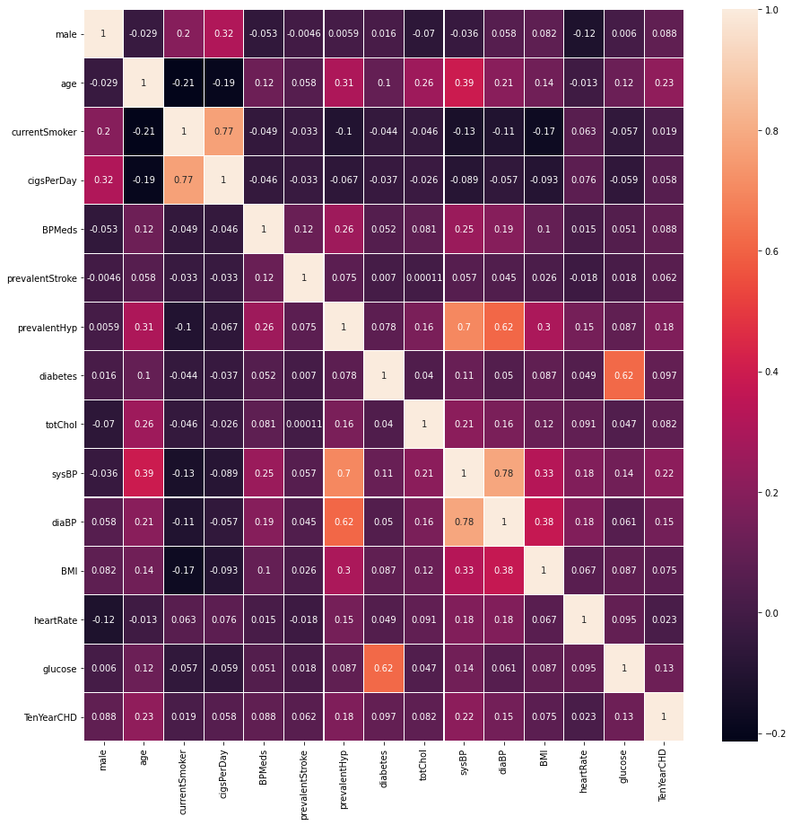
(Heat Map)
Bar Chart showing Number of People Suffer From heart disease:
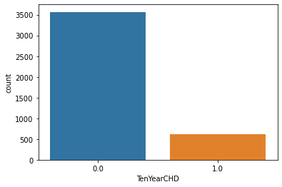

Pie Chart showning percentage of people with and wit out heart disease
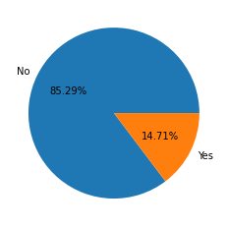
Pie chart showing male and female percentage
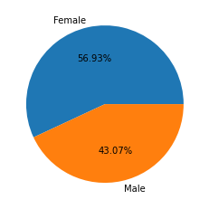

Male and Female having disease or not
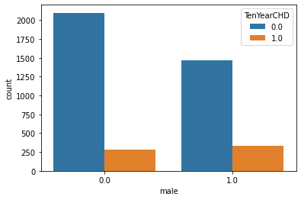
4.2.3 Algorithms
For building machine learning model following algorithms
Are used.
A.KNearest Neighbors
B.Logistic Regression
C.Decision Tree
D.Naive Bayes
E.Support Vector Machine
F.Random Forest

4.2.4 Performance Evaluation Criteria

Commonly, the performance of ML prediction systems is frequently assessed using metrics based on the classification algorithm. The accuracy, confusion matrix, and F-measure are used to evaluate the prediction findings in this research.

Confusion Matrix
A confusion matrix is used to evaluate algorithms in ML. A matrix for a binary classification problem is a square of two by two as illustrated in following Table , where the column represents the algorithm's prediction and the row reflects the real value of the class label, where true-positive (TP) is numerous positive samples accurately predicted. False-negative (FN) refers to numerous positive samples that were anticipated incorrectly. False- positive (FP) refers to a situation in which numerous negative samples are incorrectly classified as positive. A true-negative (TN) is a collection of negative samples that have been accurately anticipated .

Actual | Predict
Actual | Positive | Negative
Positive | TP | FP
Negative | FN | TN

5.GUI Implementation
A GUI is developed in python by using tkinter package to generate a simple interface which takes input for all the values necessary for evaluation. After the input is taken from the user, prompt appears which decides whether a person has a presence of heart disease or not.
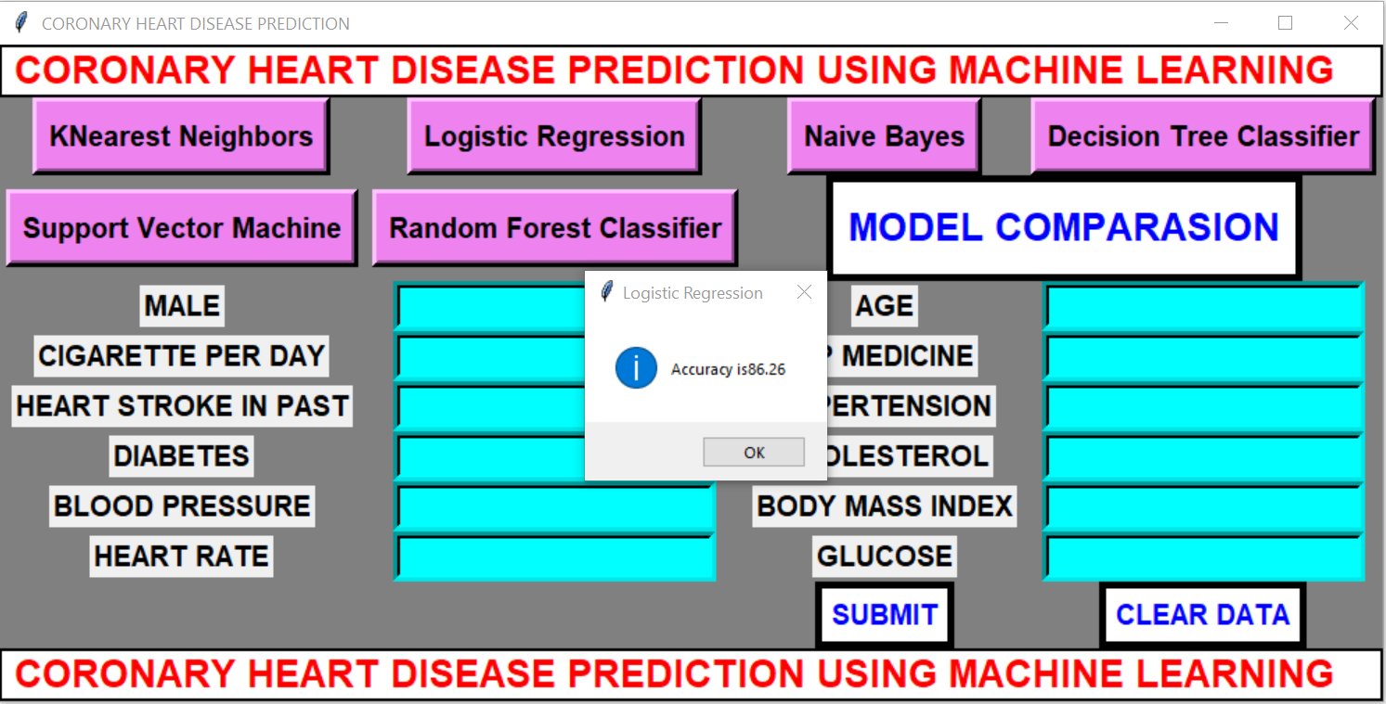

6. conclusion
- In this project six different machine learning algorithms are applied for prediction of heart disease.
- They are Logistic Regression, K-nearest Neighbours, Naïve Bayes, Decision Tree, Random Forest and SVM .
- Accuracy of Logistic Regression is 86.26%, K-nearest Neighbours is 85.42%, Naïve Bayes is 83.63%, Decision Tree is 83.03%, Random forest is 86.14% and SVM is 85.9%.
- From the above we conclude that Logistic Regression is the best model for coronary heart disease prediction.
7. Future Work
- In this project 6 machine learning algorithms are applied for prediction of coronary heart disease .It was found that Logistic Regression performs better than other algorithms. Also a GUI is developed for prediction of heart disease. In future artificial neural networks algorithms will be used to get better accuracy. Also a web based system will be developed so that people from different parts of world can use it.

